Lucas Swanson
10/2/2025
Programming Languages I
Reading 3
Exercise 1: Summarize
The BNF grammar structure can be a delicate system that, when defined improperly, can lead to ambiguity that can cause simple statements to have different parse trees, and hence different computational outcomes.

Exercise 2:
Let’s give a quick grammar definition that will cause some ambiguity and what the following parse trees would look like.
G1: <statement> : : = <statement> / <statement> | <var>
<var> : : = a | b | c
In this definition of G1, I will build a simple statement of a / b / c, which has ambiguity depending on if we interpret this in a left associative or right associative way. Here are what the parse trees would look like:
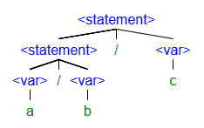
OR
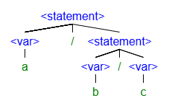
Here you can see that by following the same grammar definition in G1, we can easily build two different parse trees, which would compute as either (a/b)/c, or a/(b/c). Each of these interpretations would almost certainly have different results.

Exercise 3:
I am having a hard time with the parse tree item on the if statements on page 36. The page describes a dangling “else”, but these seem to be clearly different parse trees and also very different statements to me.
I will pull the exact trees from the text here:
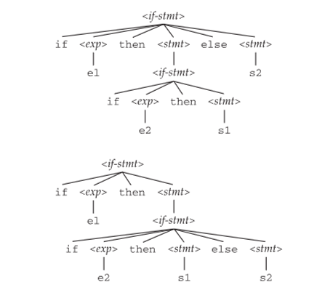
Both of these look like a nested if statement. The primary difference is which if statement gets the else statement functionally attached to it. Parse tree #1 has the else statement on the top level if statement. Parse tree #2 has the else statement applied only to the nested if statement.
Regardless of how these are interpreted these appear to be very different lines and would be parsed exactly as is.

Aka Parse Tree #1:
If (e1){
If(e2){
S1
}
}
Else{
S2
}

Where parse tree #2:
If (e1){
If(e2){
S1
}
Else{
S2
}

}

I don’t see the ambiguity as these are completely different statements.

